Temasek Polytechnic

School of Informatics and IT

**Diploma in Information Technology (IT)**

Meeting Minutes

**Project Particulars**

|  |  |
| --- | --- |
| **Tutor** | Mr Qi Yu Tao |
| **Class** | P02 |
| **Project Title** | Delonix Regia Hotel Management System |

**Project Team’s Particulars**

|  |  |
| --- | --- |
| **Matric Number** | **Student Name** |
| 1605129D | Gary Tan Jun Xian |
| 1603170J | Tang Xin Wei |
| 1602118J | Oliver Choy Chun Feng |
| 1603477I | Goh Wei Kang |
| 1605873G | Timothy Lua Wei Sheng |

|  |  |  |  |
| --- | --- | --- | --- |
| Date: | 13/11/2017 | |  |
|  |  | |  |
| Venue: | Library Hub 04-04 | |  |
|  |  | |  |
| Present: | Gary, Xin Wei, Oliver, Timothy, Wei Kang | |  |
|  |  |  | |
| Absent with apologies: | None | |  |
|  |  |  |  |

|  |  |  |  |
| --- | --- | --- | --- |
| **S/No** | **Item** | | **Action By** |
|  | Meeting started at 1:30 pm    *List out all the discussion made during interview session* | | *Write down who is doing what/ Who should pay attention to the item.* |
| **1.**  **2.**  **3.**  **4.**  **5.**  **6.**  **7.** | **Essential Modules**  There are 3 modules which are a must have for all users:   * Room availability and booking module * Housekeeping and staff module * Reporting module   Module for administrator only:   * User account and login creation module     **Level of users**:  End users:   * Reception staff * Some access to reporting module * Full access of room availability and booking module     Management users:   * Full access to all modules     Hotel administrators:   * Full access to all modules * User account & login creation module   **Room availability and booking module includes:**   * First Name & Last Name of guest * No. of adult and children * Email, phone number , home and mailing address(street, block, postal code, house no.) * Payment detail: Credit card(credit card no, credit cardholder name, expiry date) or cash * Check In details: check in dates and time, desired check out date and time. * Remarks(smokings rooms or non smoking, king size or not,late check out or not)   **Checking out process flow**   1. Guest checks out 2. Guest passes room key to reception 3. Reception asks guest if they have taken anything from the mini bar 4. Receptionist generates payment invoice 5. Receptionist will be present invoice to the guest to check and then make their payment   Payment invoice includes:   * Guest details * Check in date * Check out date * Number of nights guest stayed in the hotel * Room rates * Additional costs * Payment mode   Additional Features  Allow administrator and staff to edit the guest records as and when guest arrives at the reception   * Room Number   + If guest is not satisfied with their room and wants to change it * Details of Guest   + There may be a change in guest name as guest may have additional people coming * Number of Guest Staying   + Guest have additional people coming to stay and the hotel have to update accordingly.   **Housekeeping and Staff Management Module**  Key features:   * Allow admin to keep records of staff * Staff name, Date of Birth, Bank account, Home Address, phone number and their duty types.   **Type of housekeeping duties :**   * General maintenance * Room maintenance * Estate maintenance * Security   **Type of reports:**   * Room status   This report will lists out out all the rooms in the hotel and show whether the rooms are; vacant, occupied, vacant and scheduled for cleaning.   * Allow hotel to list all the guest in a particular room * Room guest report * List all the guest in all the rooms at any specific date * Room occupancy report   This report will generate statistics indicating the room occupancy for daily, weekly, monthly or yearly period.   * Housekeeping report allows hotel staff to list all the duties of the housekeeping staff that has been allocated to housekeeping schedule for daily, weekly and monthly schedule (administrator and management only)   **Additional features:**   * Preview of reports before before sending to print | | ALL  Gary And Xin Wei  Timothy  Wei Kang And Oliver |
| **8.** | **Budget:**  The budget that was negotiated 4 months ago is $70000 to complete the software and Mr Lim has agreed to it. Thus, the final budget is $70000.  11.Where will the software be installed  The software will be installed in a single computer at the reception staff area. The computer is relatively old. It is connected to the internet.  Specs of the computer:   * 1 GB RAM * 160 GB hard disk space * Windows XP SP2 OS * Pentium 4 CPU   The computer is also used to manage the blog-site of the hotel. | | Gary |
| **9.**  **10.**  **11.** | **Integration with other systems:**  There is no need for any integration due to the limited budget and little development time. However in the long run, it is hoped that additional features can be added.  Feature 1:   * Currently, guests have to email the hotel to inquire about room availability, which they then have to manually check the system before replying the guests. * In the long run, guests are able to inquire about room availability online.   Feature 2:   * Able to export the Reporting Module to Excel * With Excel, the hotel will be able to have numerical figures to do spreadsheets   The interviewee believes that additional features are not a priority, unless they can be certain that it can be completed within the timeframe.  **Backups**:  Hotel business operates 24/7/365. Hence, there is no actual time for a shutdown unless the hotel is going through a major renovation.  The interviewee would like the backup records to be kept in the system for five years before it can be safely discarded. He also stated that there will be a lot of activities at the reception area from 11 a.m. - 12 p.m. as that is the stipulated timing for checkout at the hotel.  If a backup must really be done, there are two options.  Option 1:   * Late in the night * For example, 2 a.m. - 3 a.m.   Option 2:   * Once a month * For example, the first Sunday of every month.   **Closing**  The interviewee would like the system to be properly installed as well as have some of his key users to be trained by 31st March. From the 7th of April, he wants the whole system to be fully deployable. | | Oliver  Xin Wei and Timothy  Wei Kang |
|  |  |  |  |
|  |  |  |  |

Meeting ended at 5:45pm

Recorded by: Tang Xin Wei

Vetted by: Timothy Lua

Temasek Polytechnic

School of Informatics and IT

**Diploma in Information Technology (IT)**

Software Requirement Specifications (SRS)

**Project Particulars**

|  |  |
| --- | --- |
| **Tutor** | Mr Qi YuTao |
| **Class** | P02 |
| **Project Title** | Delonix Regia Hotel Management System |

**Project Team’s Particulars**

|  |  |
| --- | --- |
| **Matric Number** | **Student Name** |
| 1605873G | Timothy Lua |
| 1603170J | Tang Xin Wei |
| 1603477I | Goh Wei Kang |
| 1605129D | Gary Tan Jun Xian |
| 1602118J | Oliver Choy Chen Fung |

**Table of Contents**

**DISTRIBUTION OF WORKLOAD**10

**OVERVIEW OF REQUIREMENTS**10

System Functions 10

User Characteristics 12

General Constraints 12

Functional Requirements 12

Data Requirements 15

User Interface Requirements 21

Interface with Other Systems 29

Assumptions 29

**OPERATIONAL AND QUALITY REQUIREMENTS**30

Operating Environment 30

Development Constraints 30

Performance 30

Availability 31

Security and Access Control Requirements 32

**SPECIAL REQUIREMENTS**33

**REFERENCES**33

# DISTRIBUTION OF WORKLOAD

|  |  |
| --- | --- |
| **Requirement Gathering** | **Members** |
| System Functions | All |
| User Characteristics | Gary |
| General Constraints | Gary |
| Functional Requirements | Oliver, Wei Kang and Xin Wei |
| Data Requirements | Wei Kang and Xin Wei |
| User Interface Requirements | Wei Kang and Timothy |
| Interface with other System | Oliver |
| Assumptions | Gary |
| Operating Environment | Oliver |
| Development Constraints | All |
| Performance | Xin Wei |
| Availability | Timothy |
| Security and Access Control Requirements | Timothy |

# 

# OVERVIEW OF REQUIREMENTS

## System Functions

Room availability and booking module:

Functions:

* Viewing of Available and Vacant rooms

This function allows the receptionist to be able to view how many rooms is booked and how many room is left vacant.

* Management of reservations

This function allows the receptionist to do their work smoothly as it provides a reservation calendar to be able to easily and quickly add bookings of hotel rooms and the receptionist can easily edit or add bookings to already existing reservations.

Housekeeping and staff management module:

Functions

* Assign tasks

This function allows the management to maintain their list of housekeeping staff easily. They can assign rooms based on blocks floors or sort them based on their status to manage different sections of housekeeping work.

* Create task-list

A list of housekeeping tasks that is printed and the work is easily divided and distributed to the staff on a daily basis. The management can filter and sort the room based on floors and status.

* Room maintenance

The management will have use this function to send simple task and messaging system for special requests. Maintenance and repair activities can be assigned by staff from same or other department. These tasks can be tracked for timely completion.

* Do Not Reserve

If rooms undergo maintenance or upgrades, it will not be available until the maintenance/upgrade is completed. These rooms can be marked as DNR (Do Not Reserve/Release) for the selected period.

Allow admin to keep records of staff

* Staff name, Date of Birth, Bank account, Home Address, phone number and their duty types.

Type of housekeeping duties :

* General maintenance
* Room maintenance
* Estate maintenance
* Security

Reporting module:

Type of reports:

* Room status report

This report will lists out out all the rooms in the hotel and show whether the rooms are; vacant, occupied, vacant and scheduled for cleaning.

* Listing of guests in a room report

Allow hotel to list all the guest in a particular room

* Listing of guests at a specific date in a specific room report

List all the guest in all the rooms at any specific date for example which guest is staying at room number what at 12/10/16.

* Room occupancy report|

This report generates statistics indicating the room occupancy for daily, weekly, monthly or yearly period. (Only for management and administrators)

* Housekeeping report

This report allows hotel staff to list all the duties of the housekeeping staff that has been allocated to housekeeping schedule for daily, weekly and monthly schedule (administrator and management only)

Additional features:  
Previewing of reports before sending for printing.

User account management and creation module:

* Creation of user accounts

This allows the administrator to create user accounts for the system. The administrator can choose what level of privilege the user account has, the username, and password.

* Management of user accounts

This allows the administrator to edit or delete user account

## User Characteristics

There will be three users, Reception staff, Management staff and Hotel administrators.

Reception staff:

* Some access to reporting module
* Full access of room availability and booking module

Management staff:

* Full access to all modules

Hotel administrators:

* Full access to all modules
* User account & login creation module

## General Constraints

* Manpower is limited for both client and developer side
* Hotel’s budget constraints
* Other ongoing modules
* Other outside commitments of members e.g. CCAs, part-time jobs

## Functional Requirements

Room Availability and Booking Module

Functions:

* Viewing of Available and Vacant rooms

This function allows the receptionist to be able to view how many rooms is booked and how many room is left vacant. The receptionist have to check with the system which consists of Check In Details which contains Check In Date and Time, desired Check Out Date and Time and Remarks and Room Details which contains Room Number, Room Type and Room Availability to determine the number of vacant rooms that is available.

* Management of Reservation

This function allows the receptionist to do their work smoothly as it provides a reservation calendar to be able to easily and quickly add bookings of hotel rooms.

The receptionist can easily edit or add bookings to already existing reservations. When the receptionist have to reserve a room for the guest they have to key in Customer details which consists of Guest First Name, Guest Last Name, Number of Guest staying (adults & children separately), Email, Phone Number, Home and Mailing Address (Street Name, Block number, postal code, unit number) and Country. Payment Details which consists of Credit Card (Credit Card Number, Credit CardHolder Name, Expiry Date) or Cash. Check In Details which consists of Check In Date and Time, desired Check Out Date and Time and Remarks. Room Details which consists of Room Number, Room Type, Room Availability.

Housekeeping and Staff Management Module:

* Assign tasks

This function allows the management to maintain their list of housekeeping staff easily. They can assign rooms based on blocks floors or sort them based on their status to manage different sections of housekeeping work. This function should contain data such as Staff ID, Task ID, Room Number, Status, Date Assign and Date Completed

* Create task-list

A list of housekeeping tasks that is printed and the work is easily divided and distributed to the staff on a daily basis. The management can filter and sort the room based on floors and status. This function should contain data such as Staff ID, Task ID, Room Number, Status, Date Assign and Date Completed

* Room maintenance

The management will have use this function to send simple task and messaging system for special requests. Maintenance and repair activities can be assigned by staff from same or other department. These tasks can be tracked for timely completion. This function should contain data such as Staff ID, Task ID, Room Number, Status, Date Assigned, Date Completed and Special Request

* Do Not Reserve

If rooms undergo maintenance or upgrades, it will not be available until the maintenance/upgrade is completed. These rooms can be marked as DNR (Do Not Reserve/Release) for the selected period.This function should contain data such as Room Number, Status, Date Of Reserve and Date of Completion.

Allow admin to keep records of staff

This function is to allow the administrator to keep records of all the staff that works in the hotel to be able to get their salary. This function will contain Staff details which consists of Staff Name, Date Of Birth, Bank Account, Home Address, Phone Number and their duty Types.

Reporting module:

Type of reports:

* Room status report

This report will lists out out all the rooms in the hotel and show whether the rooms are; vacant and available, occupied, vacant and scheduled for cleaning. The system should allow the user to view, add, remove, modify and printing of the report.

This report should contain data such as the hotel room ID, room availability and whether it requires to be cleaned(Housekeeping Requirement).

* Listing of guests in a room report

Allows the hotel to generate a report that lists all the guest in a particular room, including the number of children and adult staying in the room. The system should allow the user to view, add, remove, modify and printing of the report.

This report should contain data such as the guest’s first name, guest’s last name,number of adults, number of children and the room ID.

* Listing of guests at a specific date in all rooms report

The hotel will be able to generate a report that lists all the guest in all the rooms at any specific date and time for example listing all the guests in all the rooms on 12 October 2016. The system should allow the user to view, add, remove, modify and printing of the report.

This report should contain data such as the guest’s first name, guest’s last name, room ID, number of adults, number of children, current date, check in time, check out time, check in date and check out date.

* Room occupancy report|

The hotel will be able to generate a report that provides statistics indicating the room occupancy on a daily, weekly, monthly or yearly basis. This report should also include invoices of customers. This report is only accessible to the administrators as well as users at the management level. The system should allow the user to view, add, remove, modify and printing of the report.

This report should include data such as how many rooms are occupied, room types (Deluxe, Supreme, etc) and room ID were occupied on a daily, weekly, monthly and yearly basis.

* Housekeeping report

This hotel will be able to generate a report that allows hotel staff to list all the duties of the housekeeping staff that has been allocated to housekeeping schedule for daily, weekly and monthly schedule. This report is only accessible to the administrators and users at the management level. The system should allow the user to view, add, remove, modify and printing of the report.

This report should include data such such as room ID, staff first name, staff last name, staff ID, name of task, task ID, date assigned and date completed.

**Additional features of Reporting Module:**  
Previewing of reports before sending for printing.

User Account Management and Creation Module

* User creation:

This function allows the administrator to create user accounts for the system. The administrator can choose what level of privilege the user account has, the username, and password. When creating an account there are specific data that is needed and they are Staff First Name, Staff Last Name, Staff Username, Staff Password, Privilege Type.

* Managing of Account:

This function allows the administrator to edit or delete user account. When editing an account there are some data that is needed and they are Staff Username , Staff Password, Staff New Password and Privilege Type.

## Data Requirements

Room Availability and Booking Module

|  |  |  |  |  |
| --- | --- | --- | --- | --- |
| Field Name | Data Type | Field Size | Description | Example |
| GuestID | Int | 6 | Unique number for each customer | 000001 |
| GuestFirstName | Char | 12 | Gest First Name | Gary |
| GuestLastName | Char | 12 | Guest Last Name | Tan |
| NumOfRooms | Int | 1 | How many rooms the guest wants | 1 |
| NumOfChildren | Int | 2 | To let the hotel know how many children is staying | 0 |
| NumOfAdults | Int | 2 | To let the hotel know how many adults is staying | 1 |
| GuestEmail | VarChar | 60 | Guest Email to allow the hotel to know that he/ she claims to be | Gaarytan@gmail.com |
| GuestPhoneNum | Int | 15 | Phone number to determine the guest claims who he is | 84271802 |
| GuestHomeAdd | VarChar | 60 | The guest home and mailing address | Blk 11  11 Tampines Rd  #11-11  S(369011) |
| CreditCardNum | Int | 16 | Guest Credit Card Number | 1111 1111 1111 1111 |
| CreditCardHolderName | Char | 18 | Owner of the Credit Card | Gary Tan |
| ExpiryDate | Date | Date | Date that the Credit Card Expire | 22/12/2022 |
| CheckInDate | Date | Date | Date when they check in | 18/11/2017 |
| CheckInTime | Time | Time | Time that the Guest checks in | 11:11 am |
| CheckOutDate | Date | Date | Date when the guest checks out | 22/11/2017 |
| CheckOutTime | Time | Time | Time that Guest Checks out | 11:11 am |
| Remarks | VarChar | 300 | A short description of what the customers wants | Non Smoking Room |
| RoomID | Int | 3 | The Room Number | 210 |
| RoomType | Char | 10 | Room Type | Deluxe |
| RoomAvailability | Boolean | True/False | To tell whether the room is occupied or not | False |
| BookingID | Int | 10000 | To note how many bookings have been made | 00001 |

Housekeeping Module

|  |  |  |  |  |
| --- | --- | --- | --- | --- |
| Field Name | Data Type | Field Size | Description | Example |
| TaskID | Int | 2 | The Task ID | 1 |
| TaskName | Char | 60 | The Task Name | Housekeeping |
| TaskDescription | VarChar | 80 | A short Description about the task | Change Bed Sheet etc.. |
| StaffID | Int | 2 | The staff that is in charge of that task | 10 |
| RoomNum | Int | 3 | The Room that needs | 216 |
| Status | VarChar | 300 | To show the situation of the task | In Progress |
| DateAssign | Date | Date | The date that the task is assigned to | 20/11/2017 |
| DateCompleted | Date | Date | The date that the task is completed | 20/11/2017 |
| Special Request | VarChar | 600 | Additional request that is different from their normal task | Paint the wall |
| Date of Reserve | Date | Date | To show that the room is not available due to maintenance | 29/11/2017 |

Staff Management Module

|  |  |  |  |  |
| --- | --- | --- | --- | --- |
| Field | Data Type | Field Size | Description | Example |
| StaffID | Int | 2 | The ID number of the Staff | 01 |
| StaffFirstName | VarChar | 12 | The Staff First Name | James |
| StaffLastName | VarChar | 12 | The Staff Last Name | Ho |
| DateOfBirth | Date | Date | The Staff Date of Birth | 10/2/1990 |
| StaffHomeAddress | VarChar | 60 | Staff Home Address | Blk 36 Bedok North Street 82 #12-653 S(963036) |
| BankAccNum | Int | 13 | Staff Bank Account Number | 2222-222-222 |
| BankName | VarChar | 4 | Staff’s Bank | OCBC |
| DutyName | VarChar | 10 | The name of the duty the staff is in charge of | General Maintenance |
| DutyID | Int | 1 | The ID number of the Duty Type | 1 |

Report Module

|  |  |  |  |  |
| --- | --- | --- | --- | --- |
| Field Name | Data Type | Field Size | Description | Example |
| RoomID | Int | 3 | Room Number | 211 |
| RoomAvailability | Boolean | True/False | To tell whether the room is occupied or not | False |
| RoomType | Char | 10 | Room type | Deluxe |
| NumberOfRoomsOccupied | Int | 3 | The total number of rooms being occupied | 101 |
| GuestFirstName | Char | 12 | To show the guest’s first name | John |
| GuestLastName | Char | 12 | To show the guest’s last name | Smith |
| NumOfAdultGuest | Int | 1 | The number of adult guests staying in the room | Adult: 3 |
| NumOfChildrenGuest | Int | 1 | The number of children guests staying in the room | Children: 2 |
| CurrentDate | Date | Date | When the user wants to check all the rooms on a date | 12/10/16 |
| CheckInTime | Time | Time | The time the guest checked in | 11:11 am |
| CheckOutTIme | Time | Time | The time the guest checked out | 11:11 pm |
| CheckInDate | Date | Date | Date the guest checked in | 6/9/2015 |
| CheckOutDate | Date | Date | Date the guest checked out | 8/9/2015 |
| StaffFirstName | Char | 20 | To show the first name of the staff | Jane |
| StaffLastName | Char | 20 | To show the last name of the staff | Dith |
| StaffID | Int | 2 | Staff ID | 10 |
| TaskName | Char | 20 | Name of the task | Housekeeping |
| HousekeepingRequired | Boolean | True/False | To tell whether the room requires housekeeping | Requires/ Do not require |
| TaskID | Int | 2 | ID of the tasks | 1 |
| DateAssigned | Date | Date | The exact date when the task was assigned | 8/8/2016 |
| DateCompleted | Date | Date | The exact date the task has been completed | 8/8/2016 |
| TypeID | Int | 1 | Identify which report it is | 4 |
| ReportName | Varchar | 100 | Describe what kind of report it is | If it is report number 4, it is “Room Occupancy” report |
| ReportID | Int | 10000 | To note how many reports have been made | 00001 |

User Account and Creation Module

|  |  |  |  |  |
| --- | --- | --- | --- | --- |
| Field Name | Data Type | Field Size | Description | Example |
| StaffID | int | 2 | The Staff ID number that define who is who among the staff | 01 |
| StaffFirstName | Char | 16 | The Staff First Name | Bryan |
| StaffLastName | Char | 10 | The Staff Last Name | Lua |
| StaffUserName | VarChar | 16 | The Staff Username for the account | Administrator1 |
| StaffPassword | VarChar | 20 | The Staff password for their account | N0Passw0rd:v |
| Staff Privilege Type | Char | 16 | The Access level of the Staff | Administrator |

## User Interface Requirements

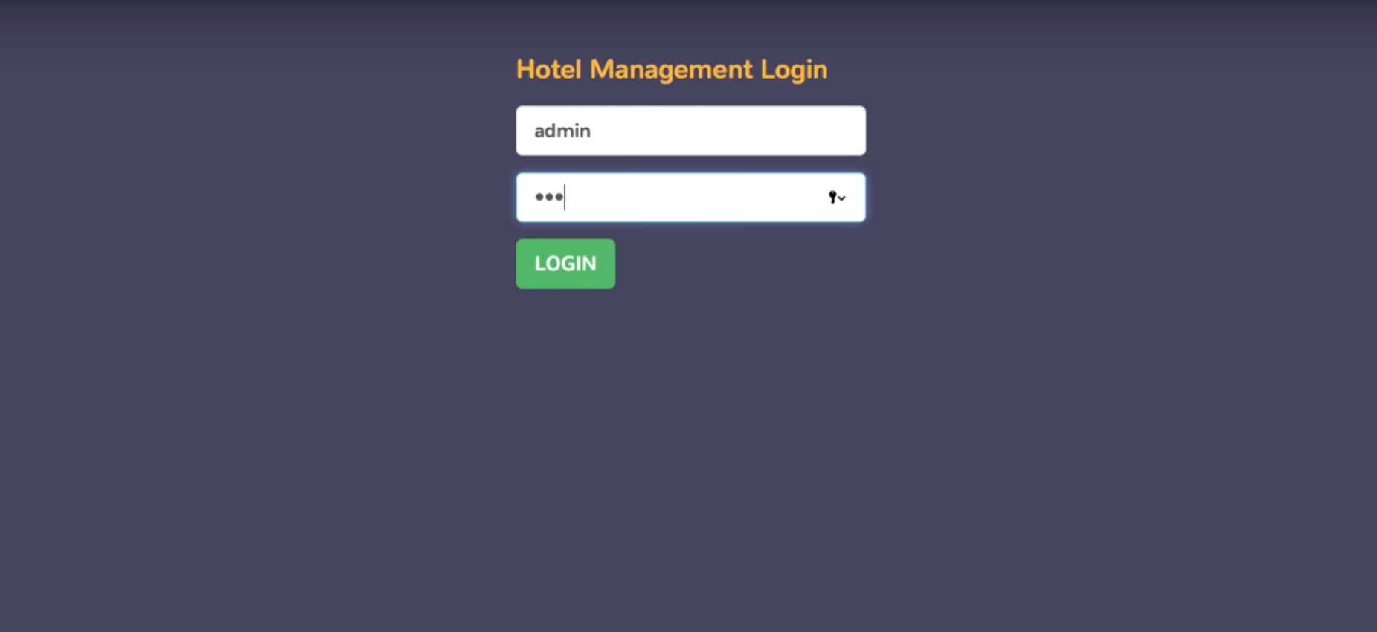

*Login Page*

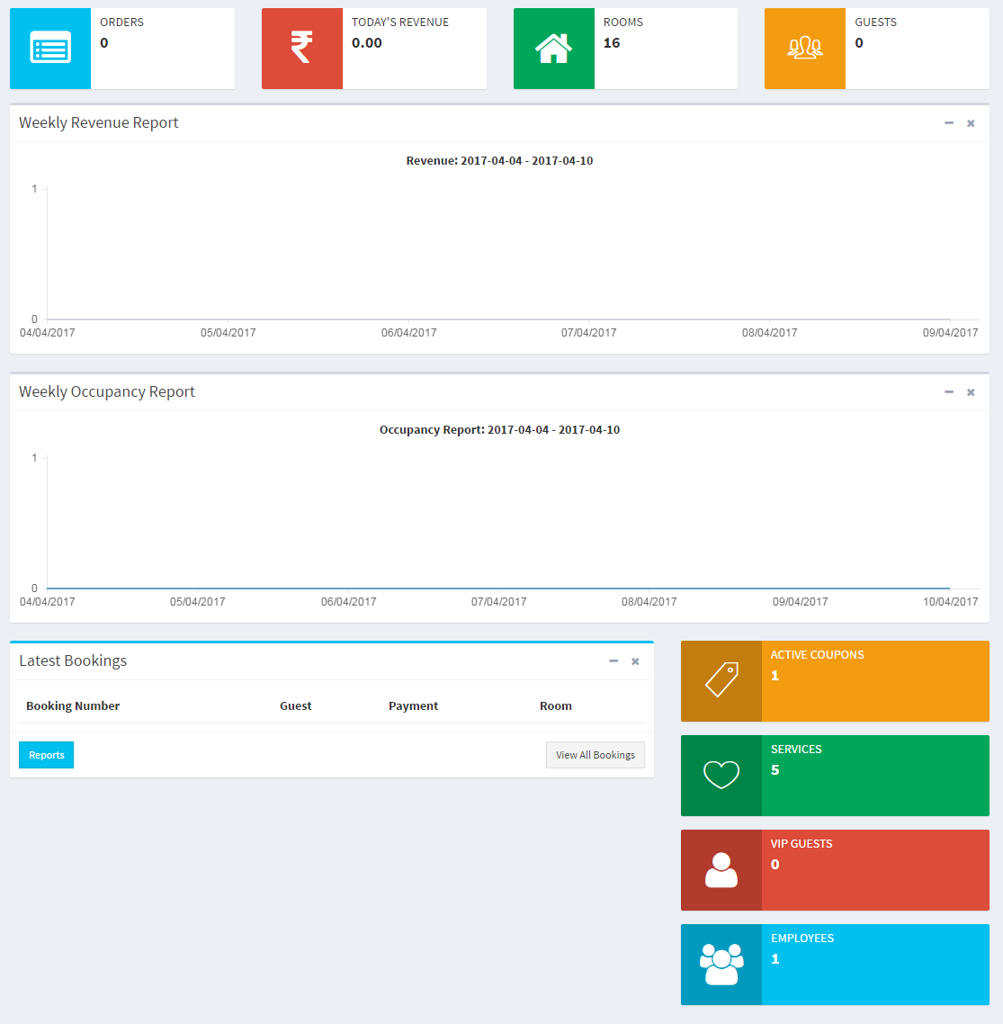

*HomePage*

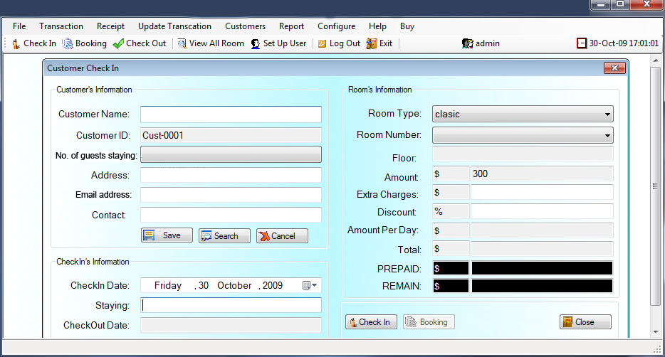

*Booking Page*

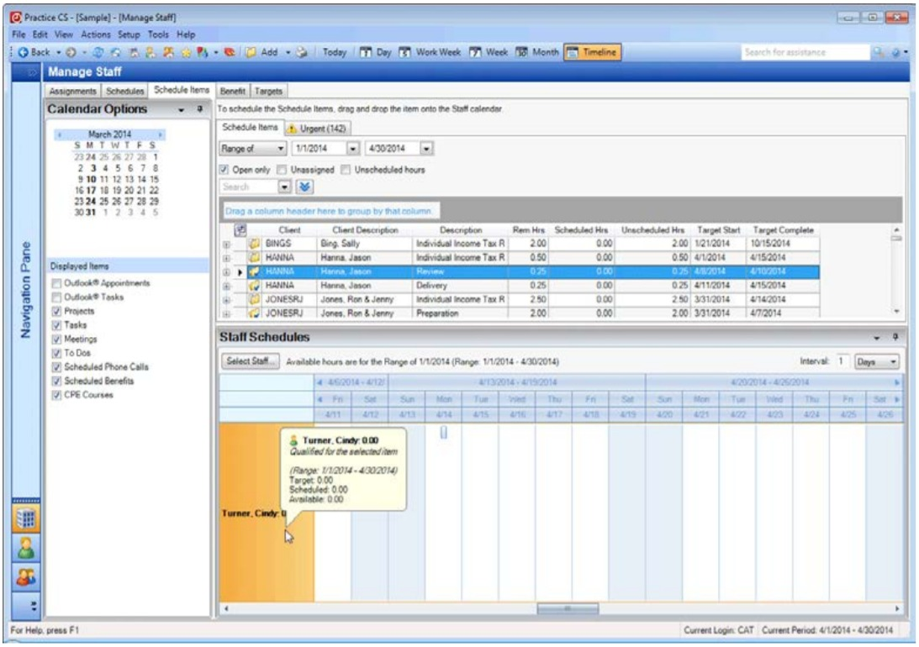

*Staff Management*

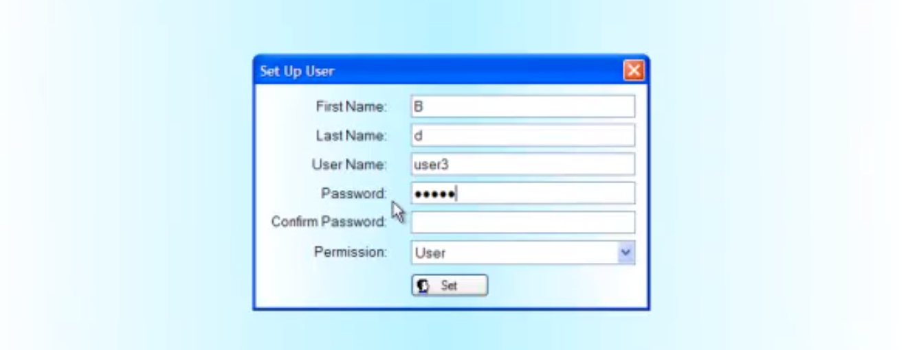

*User Creation*

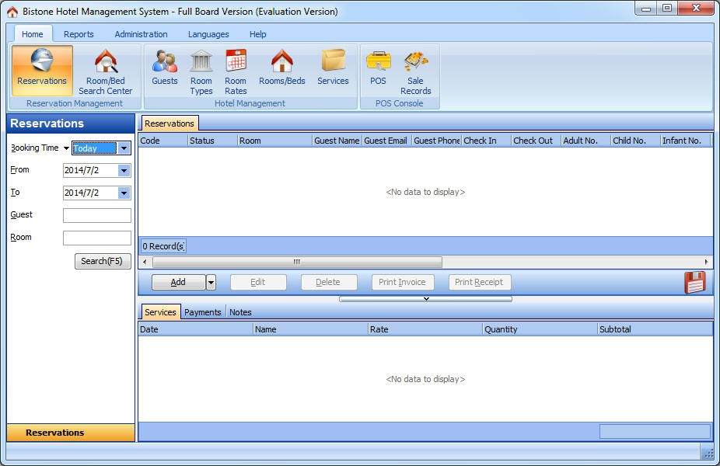

Reservation List

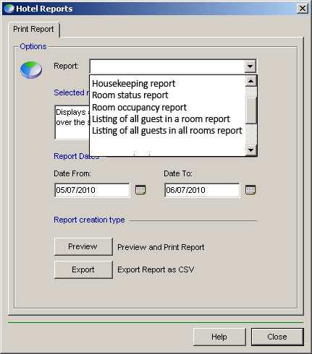

Printing of Report

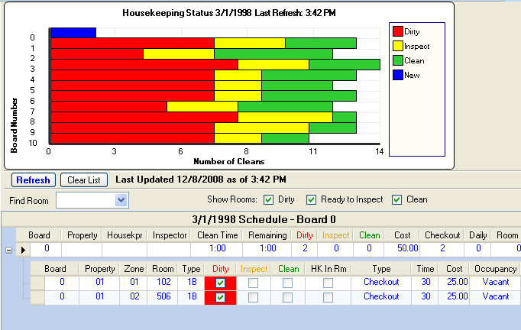

HouseKeeping Report

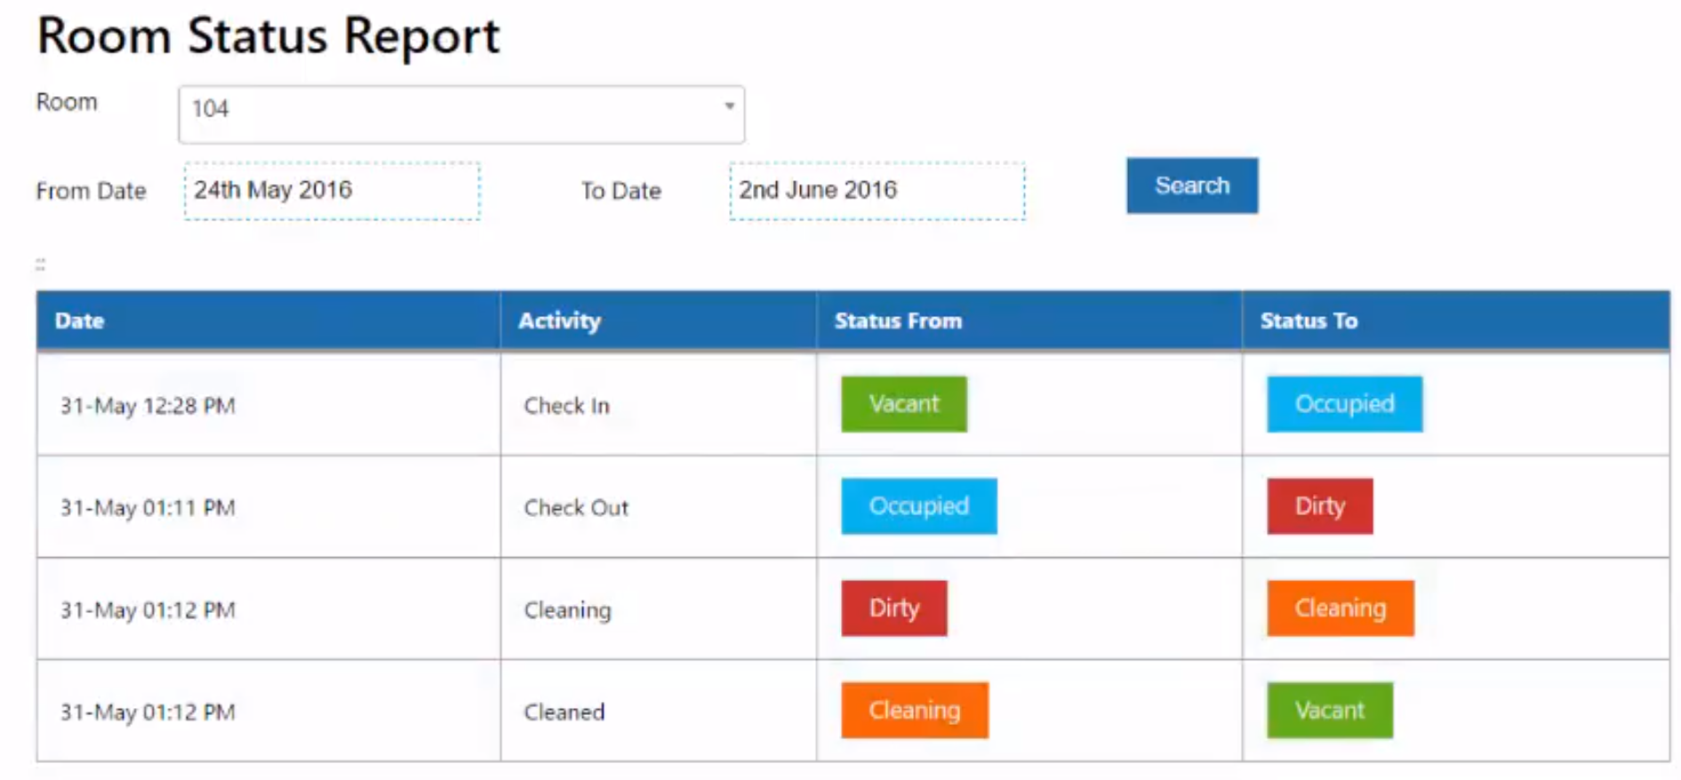

Room Status Report

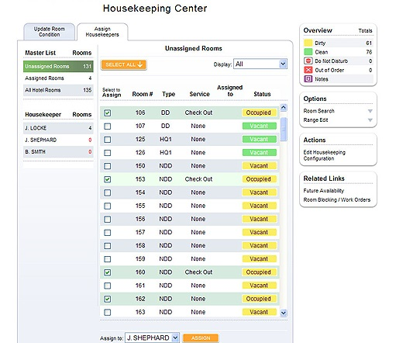

HouseKeeping Function

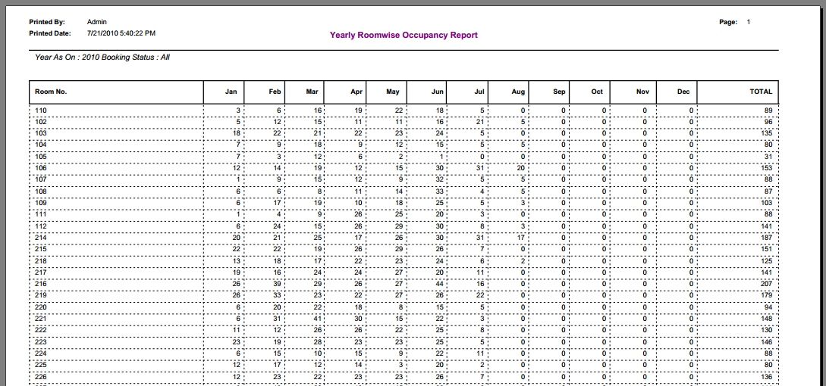

Room Occupancy Report

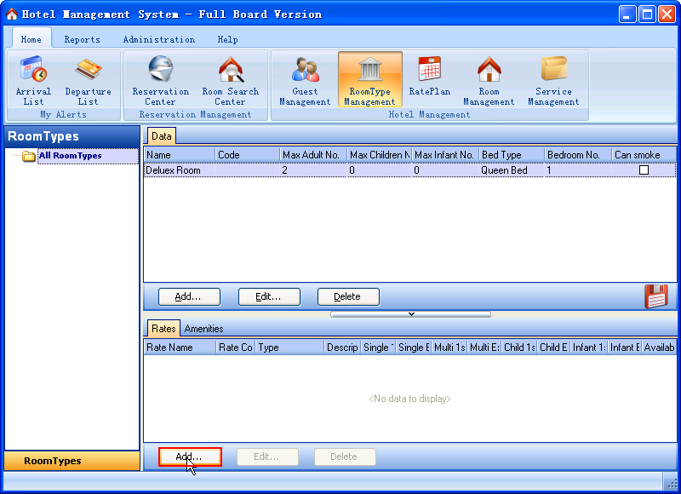

Listing of guests in a room report

## Interface with Other Systems

Room Availability and Booking Module

**Paypal/ Credit Card** - Provides customers a way to pay if they are booking online.

**Payment through third party booking systems** - Provide third party booking systems with room availability so customers may also book from them

Reporting Module

**Excel** - The user should be able to export the reports to Excel which provides the user with numerical figures to do their spreadsheets.

## Assumptions

* The hotel staff is not trained in using hotel management systems.
* Multiple users using the system full time
* The systems do not require very intense hardware requirements
* Internet connection is required
* Intranet connection is required

# OPERATIONAL AND QUALITY REQUIREMENTS

## Operating Environment

There will be two operating environments.

Operating Environment 1: Front Desk

This is the main Operating Environment for the Receptionist staff , the system will be used from 6am - 12am for this system.

Operating Environment 2: Management Room

This is the main Operating Environment for the management staff and administrators, the system is expected used during office hours.

## Development Constraints

* Software security breaches
* Software updates causing incompatibilities
* Microsoft Windows 10 is the OS used for this system development
* The latest version of Visual Studios is used for development.
* The latest version of Microsoft Office is used for development.

## Performance

Low load refers to only 1 to 5 staff using the specific module/function simultaneously.

Normal refers to 5 to 20 staff using the specific module/function simultaneously.

High load refers to 20 to 30 staff using the specific module/function simultaneously this is especially during peak hours from 11am to 12pm (check-out time). 30 staff is the max load the entire system can handle at the same time which includes all the functions of the modules.

This table will show the response times for all the functions of the modules, for the information request to be displayed.

|  |  |  |  |
| --- | --- | --- | --- |
|  | **Low load** | **Normal load** | **High load** |
| **Housekeeping and Staff Management Module** |  |  |  |
| Assign tasks | 1sec | 2sec | 4sec |
| Create task-list | 1sec | 2sec | 4sec |
| Room maintenance | 1sec | 2sec | 4sec |
| Do not reserve | 1sec | 2sec | 4sec |
| **Report Module** |  |  |  |
| Housekeeping report | 1sec | 2sec | 4sec |
| Room occupancy report | 1sec | 2sec | 4sec |
| Room status report | 1sec | 2sec | 4sec |
| Listing of guests in room report | 1sec | 2sec | 4sec |
| Listing of guests at a specific date and time in any room report | 1sec | 2sec | 4sec |
| **Room Availability and Booking Module** |  |  |  |
| View of available and vacant rooms | 2sec | 3sec | 5sec |
| Management of reservations | 2sec | 3sec | 5sec |
| **User Account Management and Creation Module** |  |  |  |
| Creation of user accounts | 1sec | 2sec | 3sec |
| Management of user accounts | 1sec | 2sec | 3sec |

## Availability

The system is required to run 24/7 for 365 days. Maintenance and backup time would be on first Sunday of every month for 3 hours from 3AM to 6AM, this is to avoid any downtime during working hours and peak period for guests checking out.

The backup records are to be kept in the system for five years before being safely discarded.

## Security and Access Control Requirements

|  |  |  |  |
| --- | --- | --- | --- |
|  | **Receptionist** | **Mangement** | **Administrator** |
| **Housekeeping and Staff Management Module** |  |  |  |
| Assign tasks | ✘ | ✔ | ✔ |
| Create task-list | ✘ | ✔ | ✔ |
| Room maintenance | ✘ | ✔ | ✔ |
| Do not reserve | ✔ | ✔ | ✔ |
| **Report Module** |  |  |  |
| Housekeeping report | ✘ | ✔ | ✔ |
| Room occupancy report | ✘ | ✔ | ✔ |
| Room status report | ✔ | ✔ | ✔ |
| Listing of guests in room report | ✔ | ✔ | ✔ |
| Listing of guests at a specific date and time in any room report | ✔ | ✔ | ✔ |
| **Room Availability and Booking Module** |  |  |  |
| View of available and vacant rooms | ✔ | ✔ | ✔ |
| Management of reservations | ✔ | ✔ | ✔ |
| **User Account Management and Creation Module** |  |  |  |
| Creation of user accounts | ✘ | ✘ | ✔ |
| Management of user accounts | ✘ | ✘ | ✔ |

# SPECIAL REQUIREMENTS

Not applicable.

# REFERENCES

None

Temasek Polytechnic

School of Informatics and IT

**Diploma in Information Technology (IT)**

Software Design Specifications (SDS)

**Project Particulars**

|  |  |
| --- | --- |
| **Tutor** | Mr Qi YuTao |
| **Class** | P02 |
| **Project Title** | Delonix Regia Hotel Management System |

**Project Team’s Particulars**

|  |  |
| --- | --- |
| **Matric Number** | **Student Name** |
| 1605873G | Timothy Lua |
| 1603170J | Tang Xin Wei |
| 1603477I | Goh Wei Kang |
| 1605129D | Gary Tan Jun Xian |
| 1602118J | Oliver Choy Chen Fung |

**Table of Contents**

**DISTRIBUTION OF WORKLOAD**36

**ARCHITECTURE DESIGN**36

**USER INTERFACE (UI) DESIGN**37

**PROGRAM DESIGN**39

**DATABASE DESIGN** **15**

# DISTRIBUTION OF WORKLOAD

|  |  |
| --- | --- |
| **Design** | **Members** |
| Architecture Design | Gary |
| User Interface(UI) Design | Timothy and Wei Kang |
| Program Design | All |
| Database Schema | Oliver and Xin Wei |

# ARCHITECTURE DESIGN

# We will be using Tier 3, the reasons we are picking tier 3 is because of Scalability, Performance, and Availability.

* Scalability—Tiers can scale horizontally.
* Performance—Because the Presentation tier can cache requests, usage of network is minimized, and the load is reduced on the Application and Data tiers. If needed, you can load-balance any tier.
* Availability—If the Application tier server is down and caching is sufficient, the Presentation tier can process Web requests using the cache.

# USER INTERFACE (UI) DESIGN

# Room Availability and Booking Module



**





**Alternate Flow:**

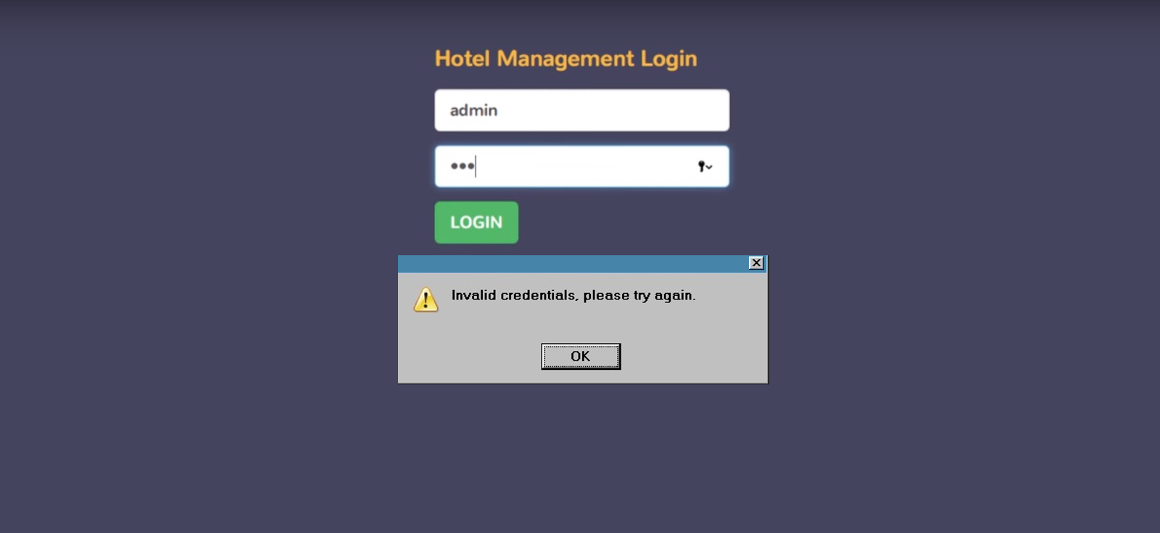

**HouseKeeping and Staff Management Module:**



**



Alternate Flow:



**Report Module-HouseKeeping Report:**



**





**Alternate Flow:**



**



# PROGRAM DESIGN

# Room Availability and Booking Module

Use case: To book a room for a guest

Use case description: The Receptionist helps the guests book and reserves a room for the guests.

Actors: Receptionist

Main Flow:

1. Receptionist logs into the system
2. Receptionist clicks on the Room Availability and Booking Module
3. Receptionist asks the guests for essential details like name,payment mode, etc
4. Receptionist records down the guest details
5. Receptionist checks for special conditions (ex. smoking room)
6. Receptionist chooses a room based on guests’ conditions if any.
7. Receptionist confirms the room or rooms with the guests
8. Receptionist gives the guests the key to the room.

Alternate Flow:

There is no smoking room available for the guest

1. Receptionist logs into the system
2. Receptionist asks the guests for essential details like name,payment mode, etc
3. Receptionist records down the guest details
4. Receptionist checks for special conditions (ex. smoking room)
5. Receptionist chooses a room based on guests’ conditions if any.
6. Receptionist confirms that smoking rooms are all filled and asks the guests if they fine with a non-smoking room
7. If the guest is fine with it, Receptionist gives the guests the key to the room.
   1. If the guest is not fine, the process ends and the guest is not given a room.

Housekeeping and Staff Management Module

Use case: Daily Housekeeping needs

Use case description: Management staff uses this module to ensure rooms are all properly taken care of.

Actors: Management Staff

Main Flow:

1. Management Staff logs into the system
2. System displays the modules available to management staff level
3. Management Staff clicks on the housekeeping and staff management module
4. Management Staff checks which staff is on duty for the day
5. System shows staff that is on duty for the day
6. Management Staff checks which rooms require housekeeping
7. System shows rooms that require housekeeping
8. Management Staff assigns the available staff to the rooms that requires housekeeping

Alternate Flow:

All rooms do not require housekeeping.

1. Management Staff logs into the system
2. System displays the modules available to management staff level
3. Management Staff clicks on the housekeeping and staff management module
4. Management Staff checks which staff is on duty for the day
5. System shows staff that is on duty for the day
6. Management Staff checks which rooms require housekeeping
7. System pops up with the message “All rooms do not require housekeeping”

Use case: Checking in the employees of the hotel

Use case description: Management Staff needs to check in the employees of the hotel, to easily check the manpower of the hotel.

Actors: Management Staff, Hotel Employees

Main Flow:

1. Management staff logs in to the system.
2. System displays the text, “You have successfully logged in!”
3. System displays the homepage.
4. Management staff selects the employee option.
5. Management staff collects the pass of the employee.
6. Management staff scans the pass of the employee.
7. System displays a text,” Employee is checked in”.
8. Management staff passes the pass back to the employee.
9. Employee is successfully checked in.

Alternate Flow:

Invalid/Faulty Employee card

1. Management staff logs in to the system.
2. System displays the text, “You have successfully logged in!”
3. System displays the homepage.
4. Management staff selects the employee option.
5. Management staff collects the pass of the employee.
6. Management staff scans the pass of the employee.
7. The scanning of the pass was not successful as the pass is spoilt.
8. Employee was not successfully checked in.

Report Module

Use case: Generate room occupancy report

Use case description: This use case allows the management/administrator to generate the room occupancy report with statistics for different periods.

Actors: Management, Administrator

Main Flow:

1. Management Staff logs into the system
2. System displays the text, “You have successfully logged in!”
3. Management Staff clicks on the report module
4. System displays the report module window
5. Management Staff selects the “Room occupancy report” from the drop down menu
6. Management Staff selects the date from period and the date to period that he wants the report to be from
7. Management staff clicks on the “Preview” button to preview the report
8. System will then display the report for the time period chosen in PDF form
9. Management staff can preview the report in the window before printing it out
10. Once management staff has checked the report he can choose to print by clicking on the “Print” button
11. System will then send a print request to the printer
12. Management staff then logs out of the system

Alternate Flow:

No PDF program

1. Management Staff logs into the system
2. System displays the text, “You have successfully logged in!”
3. Management Staff clicks on the report module
4. System displays the report module window
5. Management Staff selects the “Room occupancy report” from the drop down menu
6. Management Staff selects the date from period and the date to period that he wants the report to be from
7. Management staff clicks on the “Preview” button to preview the report
8. System will then display the report for the time period chosen in PDF form
9. The computer does not have a PDF program to view the PDF file of the report
10. Return to main flow step 7

User account management and creation module

Use case: Create an account

Use case description: This use case allows the administrator to create an account for the employees of the hotel that requires usage of the system.

Actors: Administrator

Main Flow:

1. Administrator logs into the system
2. Administrator selects the User account management and creation module
3. Administrator creates an account for the employee that needs it
4. Check which level of account to give the employee account
5. Review the account priorities
6. Choose a username and password
7. Review the account details
8. Create the account and give the account to the employee.

Alternate Flow:

Password does not meet the minimum security requirements.

1. Administrator logs into the system
2. Administrator selects the User account management and creation module
3. Administrator creates an account for the employee that needs it
4. Check which level of account to give the employee account
5. Review the account priorities
6. Choose a username
7. Choose a password
8. Review the account details
9. System pops up an error “Password does not meet the minimum security requirements.”
10. Administrator is sent back into the choosing username and password
11. Choose a more secure password
12. Review the account details again
13. Create the account and give the account to the employee.

# DATABASE DESIGN

Guest (GuestID, GuestFirstName, GuestLastName, GuestEmail, GuestPhoneNum, GuestHomeAdd, CreditCardNum)

CreditCard (CreditCardNum, CreditCardHolderName, ExpiryDate)

Booking (BookingID, GuestID, NumRooms, NumOfAdults, NumOfChildren, CheckInDate, CheckOutDate, CheckInTime, CheckOutTime, Remarks, RoomID)

Room (RoomID, RoomType, Room Availability)

Staff (StaffID, StaffFirstName, StaffLastName, DateOfBirth, StaffHomeAdd, BankNumber, BankName, StaffUsername, StaffPassword, StaffPrivilegeType, DutyID)

Duty (DutyID, DutyName)

Task (TaskID, TaskName, TaskDescription)

ReportType (TypeID, ReportName)

Report (ReportID, ReportName, TypeID, RoomID, StaffID, GuestID)

TaskAssign (TaskID, StaffID, DateAssign, DateCompleted, SpecialRequest,

DateOfReserve, Status, RoomID)

Temasek Polytechnic

School of Informatics and IT

**Diploma in Information Technology (IT)**

Team/Peer Evaluation

|  |  |
| --- | --- |
| **Project Title:**  Delonix Regia Hotel Management System | |
| **Student No:**  1605129D | **Student Name:**  Gary Tan Jun Xian |

|  |  |  |  |  |  |
| --- | --- | --- | --- | --- | --- |
| Rate the overall team performance against each criterion. Circle one number from  1 (inadequate) to 5 (superior) | | | | | |
| Team spirit | **1** | **2** | **3** | **4** | **5** |
| Overall effectiveness | **1** | **2** | **3** | **4** | **5** |
| Rewarding experience | **1** | **2** | **3** | **4** | **5** |
| Team productivity | **1** | **2** | **3** | **4** | **5** |
| Process quality | **1** | **2** | **3** | **4** | **5** |
| Product quality | **1** | **2** | **3** | **4** | **5** |

|  |  |  |  |  |  |
| --- | --- | --- | --- | --- | --- |
| Rate the contribution of each team member (including yourself). Circle one number from  1 (inadequate) to 5 (superior) | | | | | |
| Myself | **1** | **2** | **3** | **4** | **5** |
| Tang Xin Wei | **1** | **2** | **3** | **4** | **5** |
| Oliver Choy Chun Feng | **1** | **2** | **3** | **4** | **5** |
| Timothy Lua Wei Sheng | **1** | **2** | **3** | **4** | **5** |
| Goh Wei Kang | **1** | **2** | **3** | **4** | **5** |

|  |  |  |  |  |  |
| --- | --- | --- | --- | --- | --- |
| Rate the quality of work (including timeliness) of each team member (including yourself). Circle one number from 1 (inadequate) to 5 (superior) | | | | | |
| Myself | **1** | **2** | **3** | **4** | **5** |
| Tang Xin Wei | **1** | **2** | **3** | **4** | **5** |
| Oliver Choy Chun Feng | **1** | **2** | **3** | **4** | **5** |
| Timothy Lua Wei Sheng | **1** | **2** | **3** | **4** | **5** |
| Goh Wei Kang | **1** | **2** | **3** | **4** | **5** |
| Rate the help and support you have received from each team member. For yourself, rate the support and help you have given to other team members. Circle one number from  1 (inadequate) to 5 (superior) | | | | | |
| Myself | **1** | **2** | **3** | **4** | **5** |
| Tang Xin Wei | **1** | **2** | **3** | **4** | **5** |
| Oliver Choy Chun Feng | **1** | **2** | **3** | **4** | **5** |
| Timothy Lua Wei Sheng | **1** | **2** | **3** | **4** | **5** |
| Goh Wei Kang | **1** | **2** | **3** | **4** | **5** |

|  |
| --- |
| **Comments:**  The Group can clearly get work done, it’s just that we procrastinate a lot. However we |
| get it done in the end. |
|  |
|  |
|  |
|  |
|  |

**Signature: _**Gary Tan Jun Xian **___________ Date: ____**22/11/2017 **_________**

Temasek Polytechnic

School of Informatics and IT

**Diploma in Information Technology (IT)**

Team/Peer Evaluation

|  |  |
| --- | --- |
| **Project Title:**  Delonix Regia Hotel Management System | |
| **Student No:1603477I** | **Student Name: Goh Wei Kang** |

|  |  |  |  |  |  |
| --- | --- | --- | --- | --- | --- |
| Rate the overall team performance against each criterion. Circle one number from  1 (inadequate) to 5 (superior) | | | | | |
| Team spirit | **1** | **2** | **3** | **4** | **5** |
| Overall effectiveness | **1** | **2** | **3** | **4** | **5** |
| Rewarding experience | **1** | **2** | **3** | **4** | **5** |
| Team productivity | **1** | **2** | **3** | **4** | **5** |
| Process quality | **1** | **2** | **3** | **4** | **5** |
| Product quality | **1** | **2** | **3** | **4** | **5** |

|  |  |  |  |  |  |
| --- | --- | --- | --- | --- | --- |
| Rate the contribution of each team member (including yourself). Circle one number from  1 (inadequate) to 5 (superior) | | | | | |
| Myself | **1** | **2** | **3** | **4** | **5** |
| <Oliver Choy> | **1** | **2** | **3** | **4** | **5** |
| <Gary Tan> | **1** | **2** | **3** | **4** | **5** |
| <Tang Xin Wei> | **1** | **2** | **3** | **4** | **5** |
| <Timothy Lua> | **1** | **2** | **3** | **4** | **5** |

|  |  |  |  |  |  |
| --- | --- | --- | --- | --- | --- |
| Rate the quality of work (including timeliness) of each team member (including yourself). Circle one number from 1 (inadequate) to 5 (superior) | | | | | |
| Myself | **1** | **2** | **3** | **4** | **5** |
| <Oliver Choy> | **1** | **2** | **3** | **4** | **5** |
| <Gary Tan> | **1** | **2** | **3** | **4** | **5** |
| <Tang Xin Wei > | **1** | **2** | **3** | **4** | **5** |
| <Timothy Lua> | **1** | **2** | **3** | **4** | **5** |
| Rate the help and support you have received from each team member. For yourself, rate the support and help you have given to other team members. Circle one number from  1 (inadequate) to 5 (superior) | | | | | |
| Myself | **1** | **2** | **3** | **4** | **5** |
| <Oliver Choy> | **1** | **2** | **3** | **4** | **5** |
| <Gary Tan > | **1** | **2** | **3** | **4** | **5** |
| <Tang Xin Wei> | **1** | **2** | **3** | **4** | **5** |
| <Timothy Lua> | **1** | **2** | **3** | **4** | **5** |

|  |
| --- |
| **Comments:** |
| **Everyone was great. Excellent teamwork. Project Meetings were smooth.** |
|  |
|  |
|  |
|  |
|  |
|  |

**Signature: _________________WK___________ Date: ___________11/23/2017_________**

Temasek Polytechnic

School of Informatics and IT

**Diploma in Information Technology (IT)**

Team/Peer Evaluation

|  |  |
| --- | --- |
| **Project Title:**  Delonix Regia Hotel Management System | |
| **Student No:**  1605873G | **Student Name:**  Timothy Lua |

|  |  |  |  |  |  |
| --- | --- | --- | --- | --- | --- |
| Rate the overall team performance against each criterion. Circle one number from  1 (inadequate) to 5 (superior) | | | | | |
| Team spirit | **1** | **2** | **3** | **4** | **5** |
| Overall effectiveness | **1** | **2** | **3** | **4** | **5** |
| Rewarding experience | **1** | **2** | **3** | **4** | **5** |
| Team productivity | **1** | **2** | **3** | **4** | **5** |
| Process quality | **1** | **2** | **3** | **4** | **5** |
| Product quality | **1** | **2** | **3** | **4** | **5** |

|  |  |  |  |  |  |
| --- | --- | --- | --- | --- | --- |
| Rate the contribution of each team member (including yourself). Circle one number from  1 (inadequate) to 5 (superior) | | | | | |
| Myself | **1** | **2** | **3** | **4** | **5** |
| Gary Tan Jun Xian | **1** | **2** | **3** | **4** | **5** |
| Oliver Choy Chun Feng | **1** | **2** | **3** | **4** | **5** |
| Timothy Lua Wei Sheng | **1** | **2** | **3** | **4** | **5** |
| Goh Wei Kang | **1** | **2** | **3** | **4** | **5** |

|  |  |  |  |  |  |
| --- | --- | --- | --- | --- | --- |
| Rate the quality of work (including timeliness) of each team member (including yourself). Circle one number from 1 (inadequate) to 5 (superior) | | | | | |
| Myself | **1** | **2** | **3** | **4** | **5** |
| Gary Tan Jun Xian | **1** | **2** | **3** | **4** | **5** |
| Oliver Choy Chun Feng | **1** | **2** | **3** | **4** | **5** |
| Timothy Lua Wei Sheng | **1** | **2** | **3** | **4** | **5** |
| Goh Wei Kang | **1** | **2** | **3** | **4** | **5** |
| Rate the help and support you have received from each team member. For yourself, rate the support and help you have given to other team members. Circle one number from  1 (inadequate) to 5 (superior) | | | | | |
| Myself | **1** | **2** | **3** | **4** | **5** |
| Gary Tan Jun Xian | **1** | **2** | **3** | **4** | **5** |
| Oliver Choy Chun Feng | **1** | **2** | **3** | **4** | **5** |
| Tang Xin Wei | **1** | **2** | **3** | **4** | **5** |
| Goh Wei Kang | **1** | **2** | **3** | **4** | **5** |

|  |
| --- |
| **Comments:**  Parts assigned to group members are done timely of are of standard. |
|  |
|  |
|  |
|  |
|  |
|  |

**Signature: ___**Timothy Lua **___________ Date: ____**23/11/2017 **____________**

Temasek Polytechnic

School of Informatics and IT

**Diploma in Information Technology (IT)**

Team/Peer Evaluation

|  |  |
| --- | --- |
| **Project Title:**  Delonix Regia Hotel Management System | |
| **Student No:**  1603170J | **Student Name:**  Tang Xin Wei |

|  |  |  |  |  |  |
| --- | --- | --- | --- | --- | --- |
| Rate the overall team performance against each criterion. Circle one number from  1 (inadequate) to 5 (superior) | | | | | |
| Team spirit | **1** | **2** | **3** | **4** | **5** |
| Overall effectiveness | **1** | **2** | **3** | **4** | **5** |
| Rewarding experience | **1** | **2** | **3** | **4** | **5** |
| Team productivity | **1** | **2** | **3** | **4** | **5** |
| Process quality | **1** | **2** | **3** | **4** | **5** |
| Product quality | **1** | **2** | **3** | **4** | **5** |

|  |  |  |  |  |  |
| --- | --- | --- | --- | --- | --- |
| Rate the contribution of each team member (including yourself). Circle one number from  1 (inadequate) to 5 (superior) | | | | | |
| Myself | **1** | **2** | **3** | **4** | **5** |
| Gary Tan Jun Xian | **1** | **2** | **3** | **4** | **5** |
| Oliver Choy Chun Feng | **1** | **2** | **3** | **4** | **5** |
| Timothy Lua Wei Sheng | **1** | **2** | **3** | **4** | **5** |
| Goh Wei Kang | **1** | **2** | **3** | **4** | **5** |

|  |  |  |  |  |  |
| --- | --- | --- | --- | --- | --- |
| Rate the quality of work (including timeliness) of each team member (including yourself). Circle one number from 1 (inadequate) to 5 (superior) | | | | | |
| Myself | **1** | **2** | **3** | **4** | **5** |
| Gary Tan Jun Xian | **1** | **2** | **3** | **4** | **5** |
| Oliver Choy Chun Feng | **1** | **2** | **3** | **4** | **5** |
| Timothy Lua Wei Sheng | **1** | **2** | **3** | **4** | **5** |
| Goh Wei Kang | **1** | **2** | **3** | **4** | **5** |
| Rate the help and support you have received from each team member. For yourself, rate the support and help you have given to other team members. Circle one number from  1 (inadequate) to 5 (superior) | | | | | |
| Myself | **1** | **2** | **3** | **4** | **5** |
| Gary Tan Jun Xian | **1** | **2** | **3** | **4** | **5** |
| Oliver Choy Chun Feng | **1** | **2** | **3** | **4** | **5** |
| Timothy Lua Wei Sheng | **1** | **2** | **3** | **4** | **5** |
| Goh Wei Kang | **1** | **2** | **3** | **4** | **5** |

|  |
| --- |
| **Comments:**  The Group was helpful. When I needed support for 1 part my other group member came |
| and give me advice on what to do and so on. |
|  |
|  |
|  |
|  |
|  |

**Signature: ___**Tang Xin Wei **___________ Date: ____**22/11/2017 **____________**

Temasek Polytechnic

School of Informatics and IT

**Diploma in Information Technology (IT)**

Team/Peer Evaluation

|  |  |
| --- | --- |
| **Project Title:**  Delonix Regia Hotel Management System | |
| **Student No:**  1602118j | **Student Name:**  Oliver Choy Chen Fung |

|  |  |  |  |  |  |
| --- | --- | --- | --- | --- | --- |
| Rate the overall team performance against each criterion. Circle one number from  1 (inadequate) to 5 (superior) | | | | | |
| Team spirit | **1** | **2** | **3** | **4** | **5** |
| Overall effectiveness | **1** | **2** | **3** | **4** | **5** |
| Rewarding experience | **1** | **2** | **3** | **4** | **5** |
| Team productivity | **1** | **2** | **3** | **4** | **5** |
| Process quality | **1** | **2** | **3** | **4** | **5** |
| Product quality | **1** | **2** | **3** | **4** | **5** |

|  |  |  |  |  |  |
| --- | --- | --- | --- | --- | --- |
| Rate the contribution of each team member (including yourself). Circle one number from  1 (inadequate) to 5 (superior) | | | | | |
| Myself | **1** | **2** | **3** | **4** | **5** |
| Gary Tan Jun Xian | **1** | **2** | **3** | **4** | **5** |
| Oliver Choy Chun Feng | **1** | **2** | **3** | **4** | **5** |
| Timothy Lua Wei Sheng | **1** | **2** | **3** | **4** | **5** |
| Goh Wei Kang | **1** | **2** | **3** | **4** | **5** |

|  |  |  |  |  |  |
| --- | --- | --- | --- | --- | --- |
| Rate the quality of work (including timeliness) of each team member (including yourself). Circle one number from 1 (inadequate) to 5 (superior) | | | | | |
| Myself | **1** | **2** | **3** | **4** | **5** |
| Gary Tan Jun Xian | **1** | **2** | **3** | **4** | **5** |
| Oliver Choy Chun Feng | **1** | **2** | **3** | **4** | **5** |
| Timothy Lua Wei Sheng | **1** | **2** | **3** | **4** | **5** |
| Goh Wei Kang | **1** | **2** | **3** | **4** | **5** |
| Rate the help and support you have received from each team member. For yourself, rate the support and help you have given to other team members. Circle one number from  1 (inadequate) to 5 (superior) | | | | | |
| Myself | **1** | **2** | **3** | **4** | **5** |
| Gary Tan Jun Xian | **1** | **2** | **3** | **4** | **5** |
| Oliver Choy Chun Feng | **1** | **2** | **3** | **4** | **5** |
| Timothy Lua Wei Sheng | **1** | **2** | **3** | **4** | **5** |
| Goh Wei Kang | **1** | **2** | **3** | **4** | **5** |

|  |
| --- |
| **Comments:** |
| **As always, my groupmates were great and provided constructive comments during our meetups for discussion of the project. Once again, all of us attended all the project discussions.** |
|  |
|  |
|  |
|  |
|  |

**Signature: ___**Oliver Choy Chen Fung **___________ Date: ____**21/11/2017 **____________**